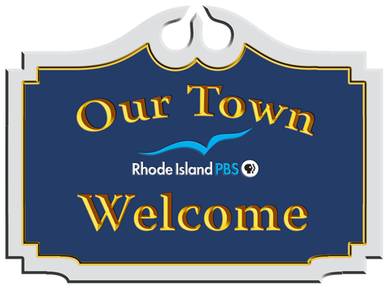

**Welcome to *Our Town***

In the *Our Town* series, Rhode Island PBS features the heritage, spirit, and local charm of small town living from *your* perspective and that of your neighbors.

Grab your video recording device and take to the streets as you document the people, places, and happenings that make your town or village special. The stories you shoot create a uniquely personal cultural tapestry and memorable keepsake for broadcast on Rhode Island PBS.

There is no charge or compensation to participate. All you need is enthusiasm and love for your home town!

We are here to help you shape your story into ***Your Voice, Your Vision,*** so call or e-mail us any time. Thanks for joining the team, and have fun!

There are more resources on our website as well:

**www.ripbs.org/our-town**

**Mark your calendar…and take some notes:**

Technical Workshop for Videographers

Date:

Time:

Location:

Live Television Premiere

Date:

Time:

Location: WSBE Rhode Island PBS studios

50 Park Lane, Providence, RI 02907

**Notes:**

**Log Sheets**

***Important:*** Make sure to fill out and hand in a log sheet with your tape. Please list the sequence of shots and accurately describe any locations or persons that need to be identified.

|  |  |  |
| --- | --- | --- |
| **Subject** | **Content Description** | **Length** |
| History of winery | Photo of first 1967 bottle | 20 seconds |
| History of winery | Photo of construction: family group photo of founders |  |
| Winery today | Exterior shot of winery: wide shot, looking at entrance | 15 seconds |
| Tasting Room | Shot of wine assortment on display shelf | 12 seconds |
|  | Printed sample of wine list distributed to tourists |  |

**Another way to participate:**

If you own a local business, you are invited to participate in *Our Town* in a way that uniquely benefits your business. *Our Town* is only made possible with the underwriting support from businesses and community organizations. Your sponsorship of *Our Town* demonstrates your hometown pride as well as your appreciation and support for local community content being developed at Rhode Island PBS.

Explore the opportunities that await you and your business in *Our Town*. Call Gretta Jacobs at 401-222-3636 x381 or email gjacobs@ripbs.org.

**Meet the Rhode Island PBS *Our Town* Team**



**How it works:**

1. Please choose one topic for a story to be included in the show. Start thinking about the story you want to tell about your town. Events, people, places, and happenings all make great stories to share. Have more than one story? Submit two! Or three!

2. Every story needs photos and video, which you will need to collect. Make sure the video and photos correspond to everything you want to tell in your feature. In addition to collecting new video or taking photos to support your story, feel free to hunt down archival photos or videos.

4. After you turn in your video, interview(s), photos, and other materials, we edit it all together into a 3-5 minute segment for the show.

5. Once we have edited all of the segments, you will be invited to an exclusive premiere screening of the show at our studios.

**Jodi Mesolella, Project Director**

401-222-3636, x209

ourtown@ripbs.org

jodim@ripbs.org

**Nicole Muri, Producer**

401-222-3636, x225

nmuri@ripbs.org

**Gretta Jacobs, Sponsorship**

401-222-3636, x381

gjacobs@ripbs.org