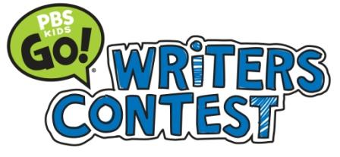
News Release
June 2, 2014
Lisa Parker Lott
601-432-6777 I lisa.parker@mpbonline.org

VICKSBURG STUDENT HONORED IN MPB WRITERS CONTEST
First Place Winners will enter National Contest this Summer

Jackson, Miss. – Vicksburg student Wesley Cowan is one of three Mississippi second grade students who placed in the Mississippi Public Broadcasting’s (MPB) annual PBS KIDS GO! Writers Contest, MPB announced today.

“It is uplifting to read the stories from these young writers,” said Ronnie Agnew, Executive Director of MPB. “At a very young age, they have learned the importance of communicating through the written word. This skill will prove valuable as they continue their academic pursuits. I can’t say enough of how proud I am of them.”

Wesley, 8, won second place in the second grade category for his story, “George the Giraffe,” which is about a giraffe who learns to eat healthy. Wesley is the son of Jennifer Cowan.

“I want kids to eat healthy,” said Wesley of why he wrote his story. A fan of carrots and fruit, Wesley noted that health can be a problem for children his age.

Panels of judges selected first, second and third place winners within each category through three separate rounds of judging. MPB hosted an awards celebration for all winners on May 30, where the children received prizes and recorded their stories in the MPB studios for placement on the MPB website.

The contest, presented locally by MPB, encourages children in grades K-3 in Mississippi and across the country to celebrate the power of language and creativity by creating and submitting original stories and illustrations. All first place winners will be entered into the national PBS KIDS GO! Writers Contest, where they will compete against area winners from across the county.

All of the winners’ stories and illustrations can be viewed at www.mpbonline.org/kidsclub.

The PBS KIDS GO! Writers Contest is produced annually by PBS KIDS and managed and created by WNED-TV Buffalo/Toronto, and is a part of PBS KIDS Raising Readers, a national initiative that uses the power of public media to build the reading skills of children ages two to eight. More information on PBS KIDS Raising Readers and the PBS KIDS GO! Writers Contest can be found at pbskids.org/read.

Mississippi Public Broadcasting (MPB) provides instructional and public affairs programming to Mississippians through its statewide television and radio network. MPB enhances the work of educators, students, parents and learners of all ages by providing informative programming and educational resources. MPB’s locally-produced programming focuses on the people, resources and attractions that reflect Mississippi’s unique culture and diverse heritage. Children’s television programs constitute a major portion of the daytime and weekend morning schedules. MPB provides a valuable resource to Mississippians in disseminating information as part of the state’s emergency preparedness and response system. Since 1970, MPB has won over 400 national, regional and statewide awards, including Emmy®, Edward R. Murrow and Parents’ Choice® Awards. For more information on MPB, its programs, mission or educational resources, please visit www.mpbonline.org.
###

