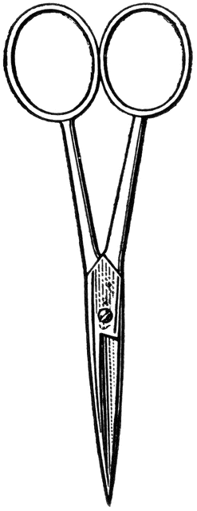

Dissection 101: Sheep Heart
Student Checklist
Name: ______________
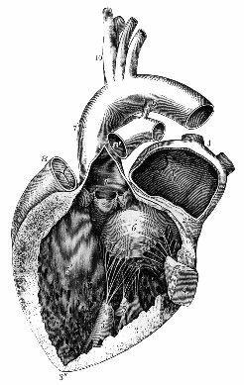
Sheep Heart Checklist: Identify the following structures/locations.
The sheep heart is an excellent specimen to use for comparative human anatomy in both size and function. The sheep heart is mammalian, having four chambers like the human heart, which includes two atria and two ventricles. The blood flow through the sheep heart is like that of the human heart, in which the blood is pumped from the right side of the heart to the lungs and then from the left side of the heart to the body.
Orientation of the heart:
- Anterior view, apex points right; posterior view, apex points left
- Anterior interventricular sulcus runs diagonal to the left; posterior interventricular sulcus runs more vertical
- The left ventricle has more resistance when pressed, because the wall (muscle) is much thicker.
- Use lines provided for additional notes
- External structures
  - Right atrium (atria: plural) – Muscular structure of the heart that pumps oxygen poor blood to the right ventricle __________________________________________________________________________________________________________
  - Left atrium (atria: plural) – Muscular structure of the heart that pumps oxygen rich blood to the left ventricle
_____________________________________________________ _____________________________________________________
  - Auricle – Outer ear like region of the left and right atria
_____________________________________________________ _____________________________________________________
  - Right ventricle – Muscular structure of the heart that pumps oxygen poor blood to the lungs
_____________________________________________________ _____________________________________________________

Dissection 101: Sheep Heart
Student Checklist (Continue page 2)

Student Checklist (Continue page 2)

  - Left ventricle – Muscular structure of the heart that pumps oxygen rich blood to the body
_____________________________________________________ _____________________________________________________
  - Apex – Inferior pointed region of the heart (left ventricle)
_____________________________________________________ _____________________________________________________
  - Larger vessels leaving the heart are called arteries and larger vessels carrying blood to the heart are called veins. __________________________________________________________________________________________________________
  - Easily identified blood vessels
    - Brachiocephalic artery – Forms right subclavian artery and common carotid artery; oxygen rich ________________________________________________________________________________________________
  - Aorta – Oxygen rich blood from left ventricle to the body ________________________________________________________________________________________________
  - Ligamentum arteriosum – Remnant of ductus arteriosus during fetal development
________________________________________________________________________________________________
- Pulmonary Trunk (artery) – Oxygen poor blood from right ventricle to lungs via right and left pulmonary arteries __________________________________________________________________________________________________
  - Superior and inferior vena cava - Supply oxygen poor blood to the right atrium from the body
__________________________________________________________________________________________________________
  - Right atrioventricular (AV) valve (also called tricuspid valve) – Prevents backflow of blood into right atrium when right ventricle pumps blood to lungs
____________________________________________________________________________________________________________
Dissection 101: Sheep Heart
Student Checklist (Continue page 3)

- Chordae tendineae - Chord like structures (tendon) that connect the tricuspid valve to the papillary muscle
______________________________________________________________________________________________________
- Papillary muscle – Contracts preventing tricuspid valve from entering the atrium when ventricle pumps blood
______________________________________________________________________________________________________
- Pulmonary semilunar valve – Prevents backflow of blood from pulmonary trunk into right ventricle
______________________________________________________________________________________________________
- Pulmonary veins – Carries oxygen rich blood from the lungs to the left atrium __________________________________________________ __________________________________________________
- Left atrioventricular (AV) valve (also called bicuspid valve or mitral valve) – Prevents backflow of blood into left atrium when left ventricle pumps blood to body _____________________________________________________________________________________________________
- Aortic semilunar valve – Prevents backflow of blood from aorta into left ventricle ___________________________________________________ ___________________________________________________

Dissection 101: Sheep Heart
Student Checklist (Continue page 4)

- Draw and label the flow of blood through the heart; include the flow of blood to the lungs and the body. Also indicate whether the blood is oxygen rich or poor.
Lungs Aorta Left ventricle Pulmonary trunk (artery)
Pulmonary veins Body Left atrium Pulmonary semilunar valve
Tricuspid valve Mitral valve Right ventricle Superior and inferior vena cava
Right atrium Aortic semilunar valve

Content provided by
Science Steve Sponsors
Images courtesy FCIT, http://etc.usf.edu/clipart

