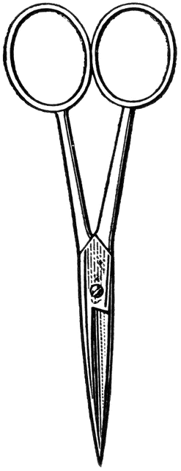

Dissection 101: Sea Star (starfish)
PowerPoint Quiz (Teacher)
Sea Star Dissection Quiz: Complete the following questions.

- Name the structure indicated. Tube feet

- What is a function of this structure? Structures are used for locomotion and capturing food (suction cup-like bottom).

- Name the structure indicated. Stone canal
- Name the structure indicated. Pyloric (hepatic) caeca or digestive glands
- What is a function of this structure? Structures of the digestive system that produce enzymes for the digestion of food.

- Which type of skeleton does the sea star have?
A. Endoskeleton or B. Exoskeleton (circle one)

- Name the structure indicated. Madreporite (sieve plate)

- What is a function of this structure? Opening (inlet) for water entering the water vascular system.

- Which sea star has the aboral side showing?
A or B (circle one)

- How do you tell which side is aboral? The aboral side is the opposite the oral side which has the mouth.
Provided by

Dissection 101: Sea Star (starfish)
PowerPoint Quiz (Teacher)

- Name the structure indicated. Gonad

- Describe the function of the water vascular system and the movement of water through it. Accept reasonable answers. The water vascular system is used for locomotion and the capturing of prey. Water enters the madreporite which is an opening (inlet) for water entering the water vascular system. Water moves from the madreporite through the stone canal which leads to the ring canal. Water moves from the ring canal to the radial canals. The radial canals bring water to the tube feet. The tube feet are structures used for locomotion and capturing food (suction cup-like bottom). The tube feet have a medicine dropper shape. The top of each tube foot has an ampulla, which is a bulbous like structure. Circular muscles contract around each ampulla forcing water down the tube foot. Longitudinal muscles along the tube feet contract forcing water back into the ampulla, causing a cuplike suction at the distal end of the tube foot.

(Optional: Draw the water vascular system)

Provided by
Provided by

