Curiosity Guide #408
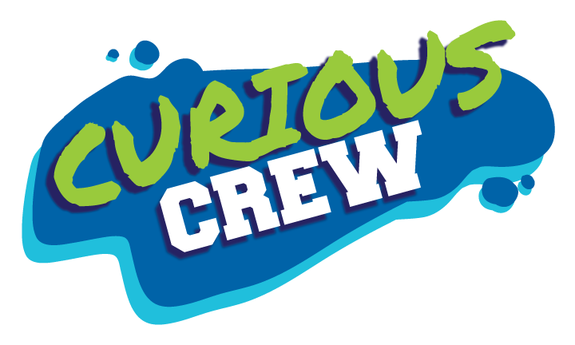

Chocolate Chemistry
Accompanies Curious Crew, Season 4, Episode 8 (#408)

Reversible Chocolate
Investigation #6

Description
Now the chocolate’s melted; now it’s not!

Materials
- Hot plate
- Cooking pan
- Metal spoon
- Measuring cup
- Chocolate bar
- Chocolate molds
- Refrigerator

Procedure
- Measure two cups of broken chocolate bars into a cooking pan.
- Heat the pan on the hot plate at medium high heat. Stir the chocolate with a metal spoon while heating.
- Pour the melted chocolate into the chocolate molds and put the molds in the refrigerator.
- When the chocolate has hardened, pop the chocolate out of the forms and enjoy!

My Results

Explanation
Some items can be reversibly changed. Melting is a process that can be reversed because melting does not change the chemical makeup. However, melting does change the substance physically. The chocolate starts in a solid state, but melts when it is heated, only to solidify once again when cooled. The chemistry has not changed. The molecules, which started as particles that were close to one another, move apart and speed up when heated. This phase change occurs when heat energy is added to the solid chocolate, which results in melting. This phase change reverses when the heat energy is removed, which results in freezing.

Think about this: Now that you’ve made or purchased some beautiful, smooth, tempered chocolate, how do you store it? First, don’t refrigerate it! You will want to keep the chocolate in a cool, dark area, ideally between 65 and 70 degrees, with low humidity. Remember, chocolate can melt at 97 degrees Fahrenheit! Another tip is to store the chocolate in an air-tight container. This is because the cocoa butter can take on the smell of other nearby objects. Yuck! Finally, dark chocolate can be stored this way for up to a year, while milk or white chocolate can be stored for only six months. Hmmm, I could just eat it now!

Parents and Educators: use #CuriousCrew #CuriosityGuide to share what your Curious Crew learned!

Curious Crew is a production of Michigan State University.
Learn more at WKAR.org.
© MSU Board of Trustees. All rights reserved.

