Curiosity Guide #408
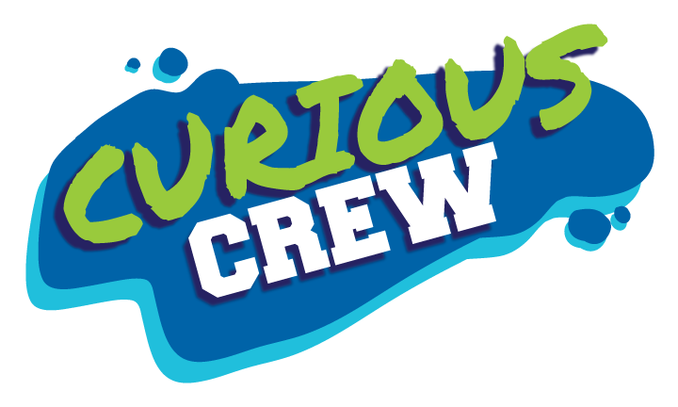

Chocolate Chemistry
Accompanies Curious Crew, Season 4, Episode 8 (#408)

Design Chocolate Bowls
STEM Challenge

Description
Yum! Create a bowl you can eat!

Materials
- Water balloons
- Wax paper
- Nonstick oil spray
- Hot plate or microwave
- Candy thermometer
- Pans, or large glass measuring cups or bowls if using a microwave
- Measuring cup
- 4 cups dark chocolate in a block, not chips
- 3 cups white chocolate in a block, not chips
- Straight pin
- Whipped cream
- Fruit
- Baking sheets or trays
- Spoons
- Sugar sprinkles for decoration
- Small bowls
- Frosting decorating bag
- Paper towels

Procedure
- Clear a good-sized space in your refrigerator to hold a baking tray with two blown-up balloons on it, and another baking tray with frosting designs.
- Blow up several water balloons, tie them closed, and set them aside.
- Cover two baking sheets with wax paper and set aside.
- Melt a pan of white chocolate and another pan of dark chocolate in the microwave or on the hot plate. You may also choose to steam-melt the chocolate. Place the solid chocolate into a bowl. Place the bowl on top of an open pan of boiling water. This will prevent the chocolate from burning.
- Stir until melted. The pans or bowls of melted chocolate don’t need to be too hot.
- Let the chocolate cool a bit, but be sure the chocolate does not begin to solidify again.
- Use the spoon to take a large spoonful of white chocolate. Make a small pool of white chocolate on the wax paper. This will become the flat base of the bowl.
- Lightly spray nonstick oil on a paper towel and smear the oil on the bottom half of a balloon.
- Dip the balloon into the pan of chocolate so the chocolate covers the half of the balloon with the oil on it. The pan should not be too wide, or the chocolate will not be deep enough.
- Lift the balloon straight up out of the chocolate.
- Stand the balloon up on its chocolate end in the pool of white chocolate.
- Repeat with another balloon.
- Place the pans of stand-up chocolatized balloons in the refrigerator to cool.
- To make chocolate accent designs, put some of the melted chocolate into a frosting decorating bag. Cut the tip off the bag or use a nozzle, and make and squeeze out thick designs on wax paper. Refrigerate the designs.
- Remove the balloon bowls from the refrigerator and pop each balloon with a pin.
- Pull out the excess latex of the balloon and discard.
- Fill the bowl with whipped cream, sliced fruit, sugar sprinkles, and the cooled chocolate designs.

My Results

Explanation
Some items can be reversibly changed. Melting is a process that can be reversed because melting does not change the chemical makeup, although the action of melting does change the solid physically. The chocolate starts in a solid state but melts when it is heated. Once the melted chocolate on the balloon has been refrigerated, the chocolate will solidify once again. The chemistry has not changed.

The molecules, which started as particles that were close to one another, move apart and speed up when heated. This phase change occurs when heat energy is added to the solid chocolate, which results in melting. The phase change reverses when the heat energy is removed, which results in freezing. The final bowls are completely edible with the rest of your snack, but don’t leave them out in the heat too long, or they will melt once again.

Something else to try in the kitchen: Here’s a fun challenge to try! Carefully remove the label from a small, clean, empty plastic soda bottle so that you can use the label again. Slowly melt one cup of chocolate, periodically removing the chocolate from the heat and stirring. Then pour some of the melted chocolate in the bottle and rotate the bottle to coat the entire inside. Lay the bottle on its side to let cool. Rotate the bottle every few minutes. When the chocolate is hard, carefully cut off the outer plastic bottle and you’ll have your very own chocolate bottle! Fill the chocolate bottle with some small candies, tape the label back on, and rest the cap on top. What fun!

Parents and Educators: use #CuriousCrew #CuriosityGuide to share what your Curious Crew learned!

Curious Crew is a production of Michigan State University.
Learn more at WKAR.org.
© MSU Board of Trustees. All rights reserved.

