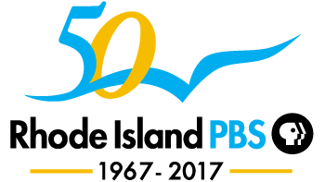

WSBE RHODE ISLAND PBS PARTICIPANT RELEASE FORM

I agree to participate in the WSBE Rhode Island PBS program titled Community Conversation: Teens and Tobacco Use and hereby authorize you to use my performance (all audio and/or video recordings) in the production of the program and for the purpose of publicizing and promoting the program. I further authorize you to broadcast the program in perpetuity.
I understand that I will receive no monetary compensation for the rights granted herein. I understand that my appearance on the program confers no ownership rights on me.
I expressly acknowledge that I am knowingly and voluntarily taking part in the program Community Conversation: Teens and Tobacco Use.
I acknowledge that I have carefully read this document in its entirety and confirm that I have the full power and authority to enter this agreement and that I accept it of my own free will.
Full Name (printed):_____________________________________________________________
Signature:_____________________________________________ Date:__________________
Address:______________________________________________________________________

FOR PARTICIPANTS UNDER 21, CONSENT OF PARENT OR GUARDIAN:
Full Name (printed):_____________________________________________________________
Signature:_____________________________________________ Date:__________________
Mother / Father / Guardian (please circle one)

