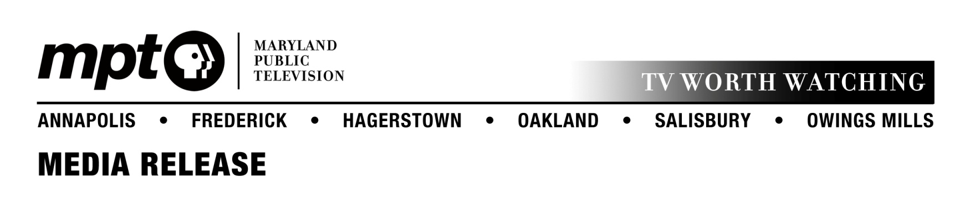
June 25, 2014
For immediate release

Contact: Mary Miles
mmiles@nevinspr.com
Office: 410-568-8821

Maryland Public Television announces second season of
Maryland Farm & Harvest

Weekly series showcases the industry that feeds Maryland

OWINGS MILLS, MD – After a successful initial 13-episode run, Maryland Public Television’s popular original series Maryland Farm & Harvest has been renewed for a second season starting in November 2014. The series puts a human face on Maryland’s agriculture industry, telling the stories of the people who grow the state’s food and fiber.

The series chronicles the successes and the challenges that local farmers face working in the state’s number one industry. Last season, Maryland Farm & Harvest featured farms across Maryland, from a soy farm in Garrett County to a horse breeding farm in Baltimore to a 10th-generation vegetable and wheat farm in Talbot County. Joanne Clendining, a veteran actress and the owner of a family farm, returns as the host for season 2.

The series airs on Tuesdays at 7 p.m. on MPT-HD and is rebroadcast on Thursdays at 11:30 p.m. and Sundays at 6 a.m. Each show will also re-air on MPT’s secondary channel, MPT2, on Fridays at 6 p.m.

The Maryland Department of Agriculture is MPT’s co-production partner for Maryland Farm & Harvest. Major funding is provided by the Maryland Grain Producers Utilization Board.

Additional funding is provided by Maryland’s Best; the Maryland Soybean Board; MidAtlantic Farm Credit; the Maryland Agricultural and Resource-Based Industry Development Corporation; the Maryland Agricultural Education Foundation; and the Maryland Association of Soil Conservation Districts. Other support comes from the Arthur W. Perdue Foundation; the Maryland Nursery & Landscape Association; the Mid-Atlantic Dairy Association; the Delmarva Poultry Industry, Inc.; Willard Agri-Service Company; the Maryland Farm Bureau Service Company, the Maryland Horse Industry Board; Harford County, Maryland, Division of Agriculture; and the Mar-Del Watermelon Association.

For more information visit mpt.org/farm.

About MPT
Launched in 1969 and headquartered in Owings Mills, MD, Maryland Public Television is a nonprofit, state-licensed public television network and member of the Public Broadcasting Service (PBS). MPT’s six transmitters cover Maryland plus portions of contiguous states and the District of Columbia. Frequent winner of regional Emmy® awards, MPT creates local, regional, and national television shows. Beyond broadcast, MPT’s commitment to professional educators, parents, caregivers, and learners of all ages is delivered through year-round instructional events and the super-website Thinkport, which garners in excess of 19 million page views annually. MPT’s community engagement connects viewers with local resources on significant health, education, and public interest topics through year-round outreach events, viewer forums, program screenings, and phone bank call-in opportunities.
###

