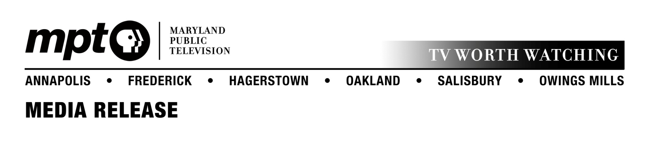
September 18, 2014
For immediate release

Contact: Mary Miles
mmiles@nevinspr.com
Office: 410-568-8821

Maryland Public Television premieres third season of Artworks

Series profiles artists, writers, composers and performers across Maryland

OWINGS MILLS, MD – Maryland Public Television’s Artworks, a weekly series featuring the movers and shakers of the art scene, returns for season three on Thursday, October 2 at 8:30 p.m.

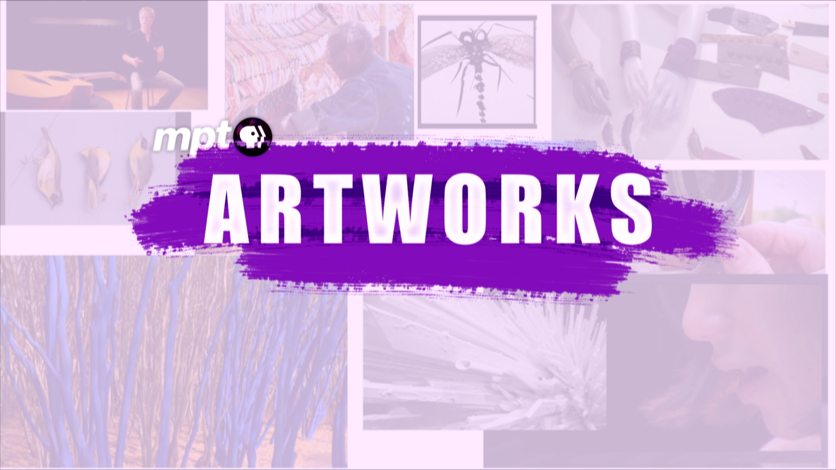
Hosted by Rhea Feikin, Artworks features the stories of established and emerging artists from across the country working in all creative categories: music, theatre, dance, visual arts, sculpture, installation art, animation, design and experimental others who defy definition.

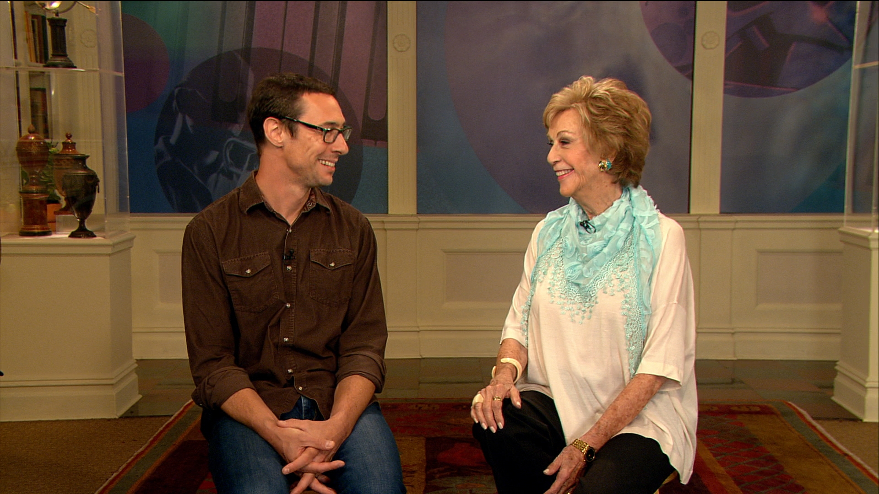
New this season, every episode of Artworks will highlight creative talent from across the Greater Baltimore-Washington D.C. area and Maryland. These include “Pop-Up Exhibits” showcasing compelling visual artists and closing music featuring some of the area’s favorite musicians and bands. The series also continues to welcome distinguished guest co-hosts from the area’s celebrated arts organizations. Season three’s premiere episode features Aaron Henkin, host and producer of WYPR’s The Signal program. Other guest co-hosts who will appear this fall include artistic directors and curators from the Baltimore Museum of Art, Baltimore Symphony Orchestra, Strathmore, Studio Theatre, and the Reginald F. Lewis Museum.
Host Rhea Feikin and WYPR's Aaron Henkin share a laugh
during filming of season three's first episode

The series airs on Thursdays at 8:30 p.m. and repeats overnight and on Sundays at 12:30 p.m., all on MPT-HD.

Fundraising efforts are underway to enable MPT to produce more segments about Maryland-area artists. Segments produced by MPT are shared with public television stations across the country, giving local artists national exposure. Major funding for Artworks is provided by the Citizens of Baltimore County.

For more information visit mpt.org/artworks.

###

