1.Title / Content Area: | Dana Crawford
2. Historic Site: | Union Station
3. Developed by: | Century Middle School Teaching Team, Adams 12 Five Star Schools
4. Grade Level and Standards:: | 3-5:  3rd: 3rd: History 1.1  4th: History 1.1, 1.2, Geography 2.1, Civics 4.1  5th: History 1.2, Geography 2.1
5. Assessment Question: | How has Dana Crawford helped to make Union Station an important place to visit and use once again?
6. Contextual Paragraph | Dana Crawford is a leader in placemaking in the United States. Many of the students we teach are unaware that without her vision and foresight, we would have the sites we are accustomed to using and seeing in downtown Denver available to public use. Her accomplishments are best described in her biography located below from her own website (http://www.danacrawford.net/bio.html#BIO)  “Award-winning preservationist Dana Crawford initiated a concept of urban renewal that was one of the first of its kind in the United States. She pioneered the redevelopment of Denver’s historic Larimer Square in the mid 1960s, creating a festival shopping area from the neglected and abandoned buildings of Denver’s original main street. Today, Larimer Square serves as a prototype for the revitalization of forgotten main streets and architectural landmarks throughout the country.  Since the 1960s, Mrs. Crawford has redeveloped more than 800,000 square feet of historic property in the city of Denver including the Oxford Hotel, the Acme Lofts, the Edbrooke Lofts and Cooper Flats Condominiums. Mrs. Crawford has been steadfast in her belief that core cities can be made livable again.”
7. Connection to Historic Preservation | Mrs. Crawford is a renowned leader in the preservation movement in Denver and in Colorado as a whole. She has given much of her time to both local and national concerns. She served nine years on the board of directors of the National Trust for Historic Preservation, six of those years on its executive committee. In 1995 the National Trust awarded her their highest honor, the distinguished Louise duPont Crowninshield Award. For fifteen years she worked with Preservation Action, serving as president for two years. She presently serves on the national board of Project for Public Spaces.  Mrs. Crawford worked tirelessly to preserve, protect, and rehabilitate Denver’s Historic Union Station. Through her work, this neo-classic building provides a central transportation hub in the city of Denver, and also provides a gathering place for community members in the many establishments housed in the building today including a rail station which has been a feature since its inception.

Document Based Question (DBQ)

Document Set
Denver Union Station Interior Photo (1915), Denver, CO | GUIDING QUESTIONS:  - What do you see in the picture of the Union Station Interior from 1915?  - What was the function of this building? How can you tell?  - What are some of the architectural elements that make this station special?
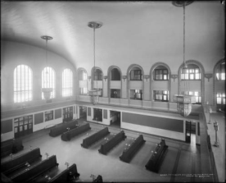

http://digital.denverlibrary.org/cdm/singleitem/collection/p15330coll22/id/10728/rec/2

Denver Union Station Interior Photo 2016, Denver, CO | GUIDING QUESTIONS:  - What are the special things (features) in Union Station today?  - How do people use the station today?  - How do these uses compare to how it was used in the past?  - What are some of the architectural elements that make this station special today?  - What features still exist compared to the original photo?
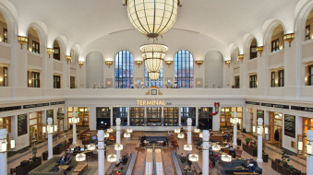

https://savingplaces.org/stories/the-creative-and-beautiful-reuse-of-denver-union-station#.WT_p6evyvIU

Secretary of Interior's Standards for Treatment of Historic Properties: Rehabilitation | GUIDING QUESTIONS:  - Who is the Secretary of Interior?  - Why do we have standards that help us preserve historic buildings?  - Read the standard here at the left. How did Dana Crawford address this standard at Union Station?
“A property will be used as it was historically or be given a new use that requires minimal change to its distinctive materials, features, spaces, and spatial relationships.

https://www.nps.gov/tps/standards/four-treatments/treatment-rehabilitation.htm

Assessment Question
How has Dana Crawford helped to make Union Station an important place to visit and use once again?
Response

