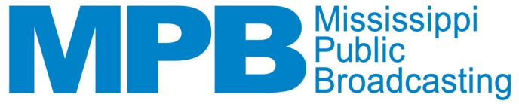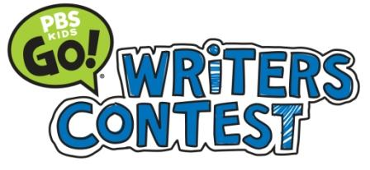
News Release
June 2, 2014
Lisa Parker Lott
601-432-6777 I lisa.parker@mpbonline.org

GULF COAST STUDENTS HONORED IN MPB WRITERS CONTEST
First Place Winners will enter National Contest this Summer

Jackson, Miss. – Five Gulf Coast-area students were selected as winners this week in Mississippi Public Broadcasting’s (MPB) annual PBS KIDS GO! Writers Contest. All first place winners will be entered into the national PBS KIDS GO! Writers Contest, where they will compete against winners from across the county.

“It is uplifting to read the stories from these young writers,” said Ronnie Agnew, Executive Director of MPB. “At a very young age, they have learned the importance of communicating through the written word. This skill will prove valuable as they continue their academic pursuits. I can’t say enough of how proud I am of them.”

Panels of judges selected first, second and third place winners within each category through three separate rounds of judging. MPB hosted an awards celebration for all winners on May 30, where the children received prizes and recorded their stories in the MPB studios for placement on the MPB website.

Kindergarten
- Third Place – Audra Freeman, 6, of Kiln – “Clover Mountain”

First Grade:
- First Place – Anton Nasrallah, 6, of Biloxi – “If I Was a Cheetah”

Second Grade:
- First Place – Lex Lu of Biloxi – “Flame”
- Third Place – Ahmad Breedlove, 8, of Biloxi – “The Hippo That Didn’t Have a Home”

Third Grade:
- Third Place – Jimm Escalante of Biloxi – “The Magician”

The contest, presented locally by MPB, encourages children in grades K-3 in Mississippi and across the country to celebrate the power of language and creativity by creating and submitting original stories and illustrations.

All of the winners’ stories and illustrations can be viewed at www.mpbonline.org/kidsclub.

The PBS KIDS GO! Writers Contest is produced annually by PBS KIDS and managed and created by WNED-TV Buffalo/Toronto, and is a part of PBS KIDS Raising Readers, a national initiative that uses the power of public media to build the reading skills of children ages two to eight. More information on PBS KIDS Raising Readers and the PBS KIDS GO! Writers Contest can be found at pbskids.org/read.

Mississippi Public Broadcasting (MPB) provides instructional and public affairs programming to Mississippians through its statewide television and radio network. MPB enhances the work of educators, students, parents and learners of all ages by providing informative programming and educational resources. MPB’s locally-produced programming focuses on the people, resources and attractions that reflect Mississippi’s unique culture and diverse heritage. Children’s television programs constitute a major portion of the daytime and weekend morning schedules. MPB provides a valuable resource to Mississippians in disseminating information as part of the state’s emergency preparedness and response system. Since 1970, MPB has won over 400 national, regional and statewide awards, including Emmy®, Edward R. Murrow and Parents’ Choice® Awards. For more information on MPB, its programs, mission or educational resources, please visit www.mpbonline.org.
###

