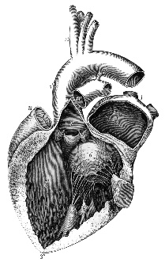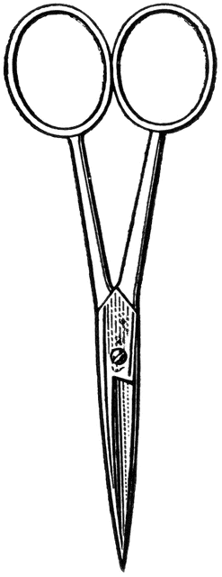**Lesson Plan: Sheep Heart Dissection**

Dissection 101:

Sheep Heart

**Background:** The sheep heart is an excellent specimen to use for comparative human anatomy in both size and function. The sheep heart is mammalian, having four chambers like the human heart, which includes two atria and two ventricles. The blood flow through the sheep heart is like that of the human heart, in which the blood is pumped from the right side of the heart to the lungs and then from the left side of the heart to the body.

To make the dissection experience for your students more relevant and to reduce the number of specimens used we have developed a collection of teacher resources for you. A teacher video (background information), interactive PowerPoint with student cut videos, a student checklist and an interactive quiz with answer key are provided below.

**Materials:**

**NOTE: The PowerPoint files are very large – PLEASE select “Save” which will reduce download time. Then, wait for the “Click” sign in the lower right corner to advance through the slides.**

* The sheep heart dissection PowerPoint ([Regular](http://pbs.bento.storage.s3.amazonaws.com/hostedbento-prod/filer_public/Learn/Dissection/SheepHeart/SheepHeartPowerPointPR.pptx) or [Show](http://pbs.bento.storage.s3.amazonaws.com/hostedbento-prod/filer_public/Learn/Dissection/SheepHeart/SheepHeartPowerPointPR.ppsx))
* Sheep heart PowerPoint quiz ([Regular](http://pbs.bento.storage.s3.amazonaws.com/hostedbento-prod/filer_public/Learn/Dissection/SheepHeart/SheepHeartQuizPowerPointPR.pptx) or [Show](http://pbs.bento.storage.s3.amazonaws.com/hostedbento-prod/filer_public/Learn/Dissection/SheepHeart/SheepHeartQuizPowerPointPR.ppsx)) (Handout: Teacher ([Doc](http://pbs.bento.storage.s3.amazonaws.com/hostedbento-prod/filer_public/Learn/Dissection/SheepHeart/SheepHeartDissectionTeacherQuizPR.docx) or [PDF](http://pbs.bento.storage.s3.amazonaws.com/hostedbento-prod/filer_public/Learn/Dissection/SheepHeart/SheepHeartDissectionTeacherQuizPR.pdf)) / Student ([Doc](http://pbs.bento.storage.s3.amazonaws.com/hostedbento-prod/filer_public/Learn/Dissection/SheepHeart/SheepHeartDissectionStudentQuizPR.docx) or [PDF](http://pbs.bento.storage.s3.amazonaws.com/hostedbento-prod/filer_public/Learn/Dissection/SheepHeart/SheepHeartDissectionStudentQuizPR.pdf))) - [Photos](https://sdpb.pbslearningmedia.org/resource/527d6e5e-82ad-4c01-baf9-573360c0122a/dissection-101-sheep-heart-dissection-photos/#.Wim32kqnFPY)
* Preservative MSDS for reference

Advance through the PowerPoint slides slowly for the PowerPoint presentations to work properly.   
(Please wait for the “Click”)

* Eyewash station available
* Shower available
* The following are for each student, pair or group.
  + - Dissection tray and pointer
    - Dissection scissors/ scalpel
    - Eye protection
    - Protective clothing (apron, lab-coat)
    - Gloves (latex free)
    - Sheep heart identification Checklist ([Doc](http://pbs.bento.storage.s3.amazonaws.com/hostedbento-prod/filer_public/Learn/Dissection/SheepHeart/SheepHeartDissectionStudentChecklistPR.docx) or [PDF](http://pbs.bento.storage.s3.amazonaws.com/hostedbento-prod/filer_public/Learn/Dissection/SheepHeart/SheepHeartDissectionStudentChecklistPR.pdf)) for students

(One for use in lab, extra copy for reference)

* + - Sheep heart
      * Example biological suppliers
        + WARDS (<http://wardsci.com>)
        + Carolina (<http://www.carolina.com>)

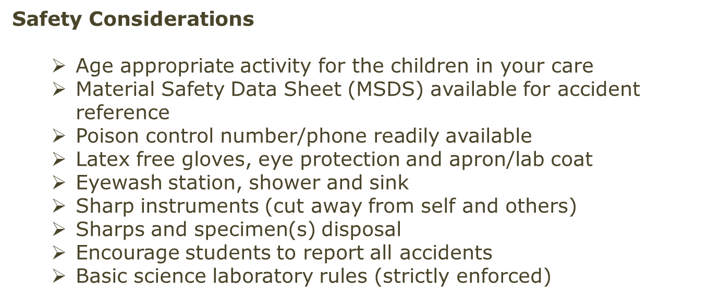



Are you looking for more science resources?

Visit Old School Demonstrations at

http://www.sdpb.org/scienceiq ([Click](http://www.sdpb.sd.gov/scienceIQ/))

Images courtesy FCIT, <http://etc.usf.edu/clipart>

Are you looking for more science resources?

Visit Old School Demonstrations at

http://www.sdpb.org/scienceiq ([Click](http://www.sdpb.org/scienceiq))

**Procedure:**

Dissection 101:

The Sheep Heart (continue – page 2)

* 1. The teacher should view the accompanying dissection video(s) (three formats below). (The video is not designed to be viewed by the students; it is designed for the teacher to review the dissection. The students may view the video if appropriate/necessary. Student video clips are in the PowerPoint.)
     + YouTube Videos (Does not work in Firefox):
     + Sheep Heart Dissection: [Part I – Exterior/Orientation](https://sdpb.pbslearningmedia.org/resource/d5201c57-3edf-436f-81f7-ba884b2e0e66/detailed-sheep-heart-dissection-video-part-i/#.Wim6MEqnFPY) ([YouTube](https://www.youtube.com/watch?v=iYKhrjfkMwA&list=PLCvVBOK6lIHvHf2xqX0p7BMqf32oJsuP9&index=37))
     + Sheep Heart Dissection: [Part II – Dissection](https://sdpb.pbslearningmedia.org/resource/9d6854af-12ef-4b20-bcac-0c769c6f9337/detailed-sheep-heart-dissection-video-part-ii/#.Wim6eEqnFPY) ([YouTube](https://www.youtube.com/watch?v=HNxSC244Bpo&list=PLCvVBOK6lIHvHf2xqX0p7BMqf32oJsuP9&index=38))
  + Downloadable Version:
    - [Entire Video](http://pbsdll.k12.sd.us/Asset.aspx?ID=692&C=All&G=All&S=sheep%20heart) (Player works best in Explorer)
  1. Gather the materials listed above.
* Include the interactive PowerPoint ([Regular](http://pbs.bento.storage.s3.amazonaws.com/hostedbento-prod/filer_public/Learn/Dissection/SheepHeart/SheepHeartPowerPointPR.pptx) or [Show](http://pbs.bento.storage.s3.amazonaws.com/hostedbento-prod/filer_public/Learn/Dissection/SheepHeart/SheepHeartPowerPointPR.ppsx)) presentation for the laboratory projector/screen.
  1. Review safety concerns/rules with students.
  2. Lead the dissection by advancing through the PowerPoint presentation; the students should identify the parts shown.
  3. 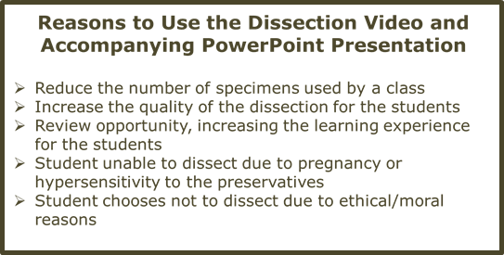The students should check off the sheep heart parts on the Student Checklist ([Doc](http://pbs.bento.storage.s3.amazonaws.com/hostedbento-prod/filer_public/Learn/Dissection/SheepHeart/SheepHeartDissectionStudentChecklistPR.docx) or [PDF](http://pbs.bento.storage.s3.amazonaws.com/hostedbento-prod/filer_public/Learn/Dissection/SheepHeart/SheepHeartDissectionStudentChecklistPR.pdf)) once they are identified. An extra, clean copy should be given to the students for review.
  4. Clean the facility/materials and dispose of specimens properly.
  5. Quiz the students during the next class period.
     + Save the sheep hearts and pin the actual parts. (or)
     + Sheep heart quiz PowerPoint ([Regular](http://pbs.bento.storage.s3.amazonaws.com/hostedbento-prod/filer_public/Learn/Dissection/SheepHeart/SheepHeartQuizPowerPointPR.pptx) or [Show](http://pbs.bento.storage.s3.amazonaws.com/hostedbento-prod/filer_public/Learn/Dissection/SheepHeart/SheepHeartQuizPowerPointPR.ppsx)) (Handout: Teacher ([Doc](http://pbs.bento.storage.s3.amazonaws.com/hostedbento-prod/filer_public/Learn/Dissection/SheepHeart/SheepHeartDissectionTeacherQuizPR.docx) or [PDF](http://pbs.bento.storage.s3.amazonaws.com/hostedbento-prod/filer_public/Learn/Dissection/SheepHeart/SheepHeartDissectionTeacherQuizPR.pdf)) / Student ([Doc](http://pbs.bento.storage.s3.amazonaws.com/hostedbento-prod/filer_public/Learn/Dissection/SheepHeart/SheepHeartDissectionStudentQuizPR.docx) or [PDF](http://pbs.bento.storage.s3.amazonaws.com/hostedbento-prod/filer_public/Learn/Dissection/SheepHeart/SheepHeartDissectionStudentQuizPR.pdf)))

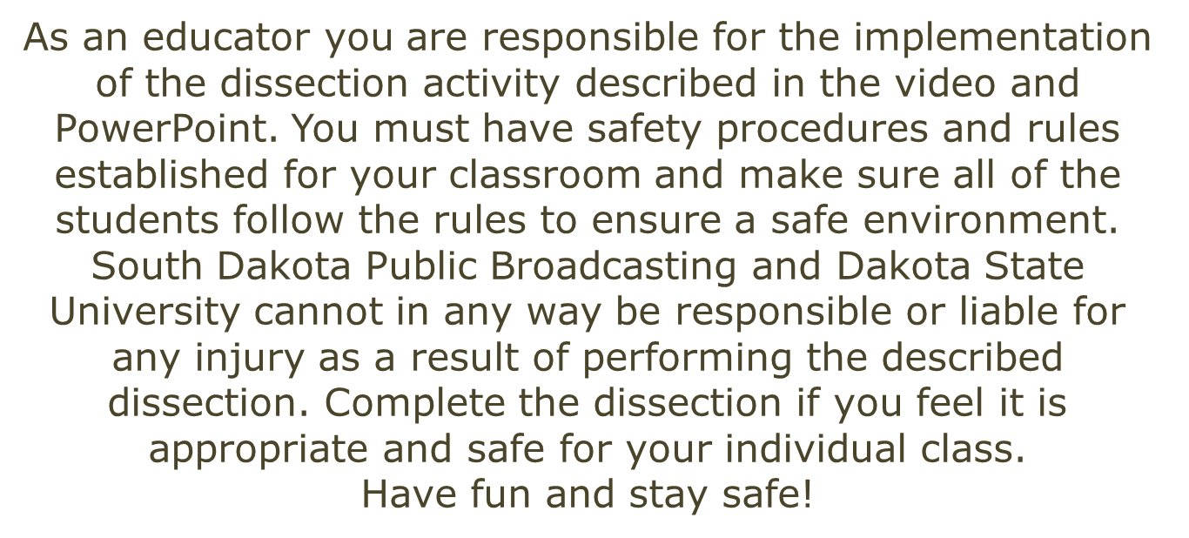



Images courtesy FCIT, <http://etc.usf.edu/clipart>

Are you looking for more science resources?

Visit Old School Demonstrations at

<http://www.sdpb.org/scienceiq> ([Click](http://www.sdpb.org/scienceiq))