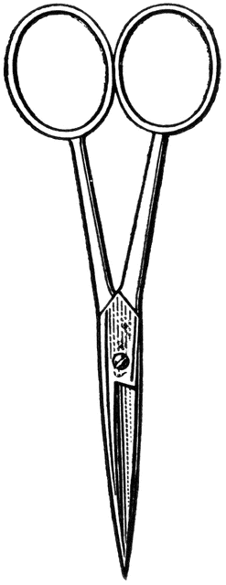

Dissection 101: Sea Star (starfish)
PowerPoint Quiz (Student)
Sea Star Dissection Quiz: Complete the following questions.

- Name the structure indicated. _________________________
- What is a function of this structure? _______________________________ _____________________________________________________________
- Name the structure indicated. _________________________
- Name the structure indicated. _________________________
- What is a function of this structure? ______________________________ ____________________________________________________________

- Which type of skeleton does the sea star have?
A. Endoskeleton or B. Exoskeleton (circle one)

- Name the structure indicated. __________________________
- What is a function of this structure? ______________________________ ____________________________________________________________

- Which sea star has the aboral side showing?
A or B (circle one)
- How do you tell which side is aboral?______________________________ _____________________________________________________________

- Name the structure indicated. __________________________
Provided by

Dissection 101: Sea Star (starfish)
PowerPoint Quiz (Student)

- Describe the function of the water vascular system and the movement of water through it._______________________________________________ ________________________________________________________________________________________________________________________________________________________________________________________________________________________________________________________________________________________________________________________________________________________________________________________________________________________________________________________________________________________________________

(Optional: Draw the water vascular system)

Provided by
Provided by

