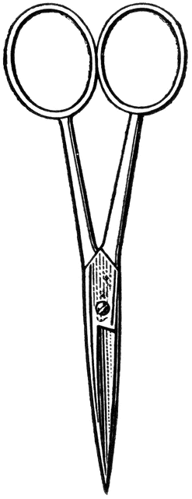

Dissection 101: Sea Star (starfish)
Student Checklist
Name: ______________
Sea Star Checklist: Identify the following structures/locations.
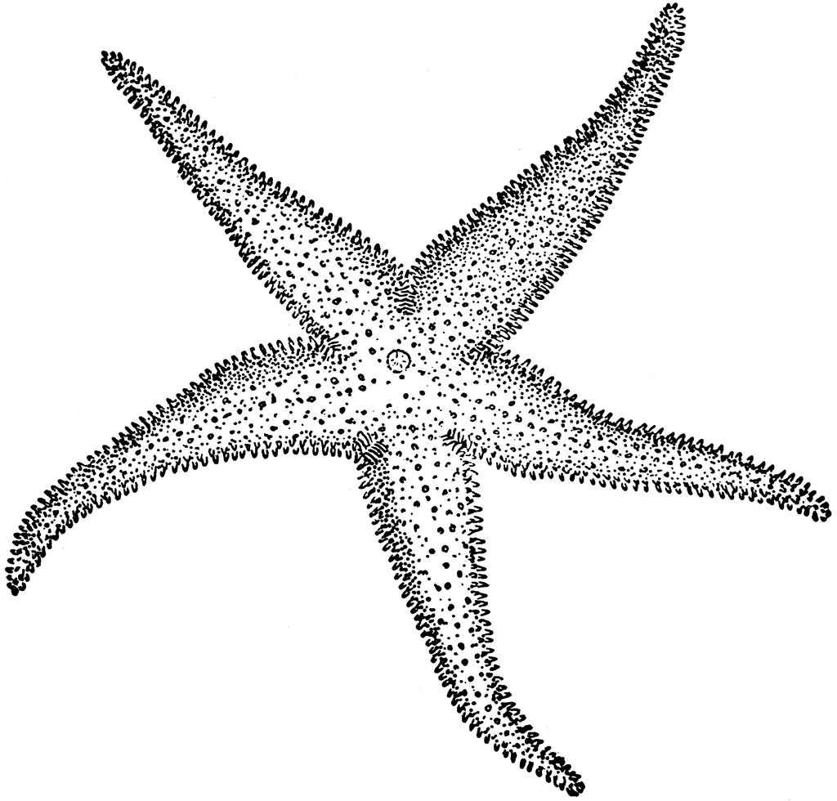
Sea stars (starfish) are echinoderms, which are an unusual group of marine animals.
- Use lines provided for additional notes
- External structures
  - Orientation
    - Top view, also called the aboral (opposite mouth) surface. ________________________________________________________________________________________________
    - Bottom view, also called the oral surface. ________________________________________________________________________________________________
    - Radial symmetry: Circular body plan in which there is a central disk (circular body region) with elements (arms, normally 5 (pentamerous)) that radiate from the central region
________________________________________________________________________________________________
      - Regeneration: The growth/replacement of damaged parts like arms. ________________________________________________________________________________________
  - Endoskeleton: The skeleton of the sea star is located beneath/within the skin; sometimes referred to as a dermal endoskeleton. Provides support/protection. __________________________________________________________________________________________________________
  - Madreporite (sieve plate): Opening (inlet) for water entering the water vascular system. __________________________________________________________________________________________________________
Provided by
Dissection 101: Sea Star (starfish)
Student Checklist (Continue page 2)
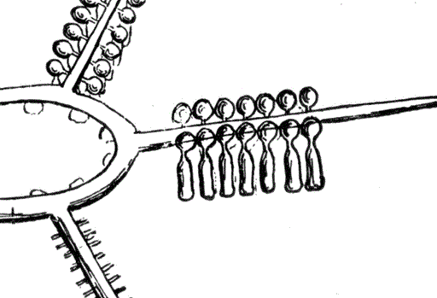
  - Mouth: Opening into the digestive system. ______________________________________________________________________________________________
  - Tube feet: Structures that are used for locomotion and capturing food (suction cup-like bottom). The tube feet have a medicine dropper shape.
__________________________________________________________________________________________________________
- Internal Structures
  - Pyloric (hepatic) caeca or digestive glands: Structures of the digestive system that produce enzymes for the digestion of food. _____________________________________________________ _____________________________________________________
  - Gonads: There are a pair of gonads in each arm; the male and female gonads are difficult to distinguish when preserved; external fertilization in water. __________________________________________________________________________________________________________
  - Stomachs
    - Pyloric stomach: The portion of the 2 part stomach that lies closest to the aboral (opposite mouth) surface of the central disk. Connected to pyloric caeca by ducts. Thin walled; this structure is often damaged when the endoskeleton is removed. ________________________________________________________________________________________________
  - Rectal Bursa (caeca): Structure may function to store waste.

    - Cardiac stomach: The thicker walled cardiac stomach (oral/lower section of stomach) can extend outward from the mouth, using digestive juices to dissolve its prey. Tiny hairs (cilia) then move the liquid to the pyloric stomach.

Provided by
Dissection 101: Sea Star (starfish)
Student Checklist (Continue page 3)
  - Water vascular system: Locomotion and the Capturing of Prey.
    - Madreporite (sieve plate): Opening (inlet) for water entering the water vascular system.
________________________________________________ ________________________________________________
    - Stone canal: Transfers water from madreporite to the ring canal. ________________________________________________________________________________________________
    - Ring canal: Transfers water from stone canal to the radial canals. ________________________________________________ ________________________________________________
    - Radial canals: Transfers water from ring canal to the tube feet. ________________________________________________________________________________________________
    - Tube feet: Structures that are used for locomotion and capturing food (suction cup-like bottom). The tube feet have a medicine dropper shape.
________________________________________________________________________________________________
      - Ampulla – A bulbous like structure at the top of each tube foot. Circular muscles contract around each ampulla forcing water down the tube foot. Longitudinal muscles along the tube feet contract forcing water back into the ampulla, causing a cuplike suction at the distal end of the tube foot.
________________________________________________________________________________________

Provided by
Dissection 101: Sea Star (starfish)
Student Checklist (Continue page 3)

  - Draw and label the water vascular system.

Radial canals Tube feet Ampulla
Ring canal Stone canal Madreporite (sieve plate)

Images courtesy FCIT, http://etc.usf.edu/clipart

Provided by

