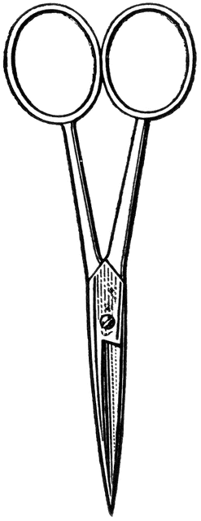

Dissection 101: Crayfish
PowerPoint Quiz (Teacher)
Crayfish Dissection Quiz: Complete the following questions.

- Name the structure indicated. Mandibles

- What is a function of this structure? Break food apart

- Name the structure indicated. Gills

- Name the structure indicated. Chelipeds

- What is a function of this structure? – Defense, fighting and capturing prey

- Male, female or both?
A. Male B. Female C. Both

- Name the structure indicated. Stomach (cardiac and pyloric)

- What is a function of this structure? Storage and digestion

- Name the structure indicated. Antennal glands (green glands)

Dissection 101: Crayfish
PowerPoint Quiz (Teacher)

- What is a function of this structure? Excretion of body wastes (equivalent to urine)

- What is one characteristic of arthropods (describe)?
- Jointed appendages – bend to move in specific directions and
specialized for specific jobs
- Exoskeleton – hardened cuticle, which is an outside layer of skin; it is nonliving tissue called chitin that does not grow with the body and must be removed for growth in a process called molting (shedding)
- Body segmentation – specific regions

- What is the structure indicated? Swimmerets

- Describe how the abdomen (tail) moves the crayfish through the water.
Propels the crayfish in a backward direction by whipping the tail forward (third law of motion)

Images courtesy FCIT, http://etc.usf.edu/clipart

Provided by
Science Steve Sponsors
Provided by

