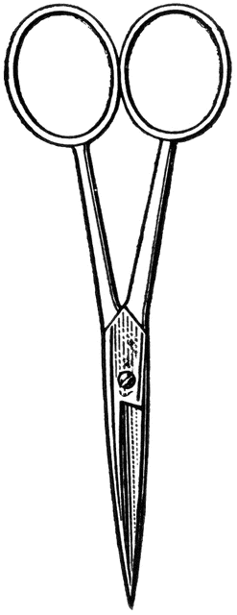

Dissection 101: Crayfish
Student Checklist
Name: ______________
Crayfish Checklist: Identify the following structures/locations.
Crayfish are arthropods, which are the most diverse and abundant group of animals on earth. There are more species of arthropods than all other animals combined.
Arthropod characteristics:
- Jointed appendages – bend to move in specific directions and specialized for specific jobs
- Exoskeleton – hardened cuticle, which is an outside layer of skin; it is nonliving tissue called chitin that does not grow with the body and must be removed for growth in a process called molting (shedding)
- Body segmentation – specific regions
- Use lines provided for additional notes
- External structures
  - Regions (two)
    - Cephalothorax – head and thorax region ________________________________________________________________________________________________
    - Abdomen – segmented tail ________________________________________________________________________________________________
- The telson (single – middle section) and uropods (two – outer sections) form the flipper-like structure at the end of the abdomen (tail); used to propel the crayfish in a backward direction (third law of motion) ________________________________________________________________________________________
Dissection 101: Crayfish
Student Checklist (Continue page 2)

Student Checklist (Continue page 2)

  - Chelipeds (pinchers) – 1st of the paired walking legs; modified for defense, fighting and capturing prey (can regenerate, but slow) __________________________________________________________________________________________________________
  - Antennae – 2 pair, smaller anterior paired called antennules; used for taste (chemicals in water) & touch __________________________________________________________________________________________________________
  - Carapace – specialized portion of the exoskeleton; covers the head and thorax regions
__________________________________________________________________________________________________________
  - Rostrum – anterior section of carapace; protects eyes/head
__________________________________________________________________________________________________________
  - Walking legs – 4 pair of jointed legs; for movement __________________________________________________________________________________________________________

  - Maxillipeds – 3 pair of larger appendages near mouth; handle food
__________________________________________________________________________________________________________

  - Mandibles – Jaw like structure; move side to side to break food apart
__________________________________________________________________________________________________________
  - Swimmerets - structures used to help propel crayfish through the water; move water across gills; hold fertilized eggs and larva in females
__________________________________________________________________________________________________________

    - Male – First 2 pair of swimmerets are hardened/enlarged (copulatory swimmerets); used to deposit sperm from opening of sperm duct to seminal receptacle of female
________________________________________________________________________________________________
Dissection 101: Crayfish
Student Checklist (Continue page 3)

    - Female (L) – Has a seminal receptacle which is an opening to the female reproductive system (eggs expelled and held by swimmerets after they are fertilized)
________________________________________________________________________________________________
    - Anus – Complete digestive system
________________________________________________________________________________________________
- Internal Structures
  - Gills - Feather-like structures (increased surface area); used to remove oxygen from water for respiration _____________________________________________________ _____________________________________________________
  - Heart (may be attached to the carapace) - Open circulatory system; keeps blood moving under low pressure __________________________________________________________________________________________________________
  - Digestive gland – Produce enzymes to digest food; absorption of nutrients ___________________________________________________ ____________________________________________________
  - Stomach – Storage and digestion – 2 chambered: cardiac stomach is anterior (closer to the mouth), has a gastric mill which is a teeth-like structure used to break food into smaller pieces; pyloric stomach connects to the intestine
    - Cardiac Stomach
________________________________________________________________________________________________
    - Pyloric Stomach.
________________________________________________________________________________________________
  - Antennal glands (green glands) – Paired; excretion of body wastes (equivalent to urine)
__________________________________________________________________________________________________________

Dissection 101: Crayfish
Student Checklist (Continue page 4)

  - Ganglia – Nervous tissue
__________________________________________________________________________________________________________
  - Intestine – Passage of undigested food from the stomach to the anus (complete digestive system)
__________________________________________________________________________________________________________

▪ Draw and label the external structures of the crayfish.

telson carapace chelipeds
walking legs abdomen cephalothorax
rostrum antennae uropod

Science Steve Sponsors
Images courtesy FCIT, http://etc.usf.edu/clipart

Content provided by

